Shrew Retching Analysis

Video Recordings:

Single video on 10/19/2021 of 4 isolated shrews having received 5mg/ml/kg nicotine.

Video trimmed to 11 minutes: nicotine_emesis_10.19.21_all.mp4

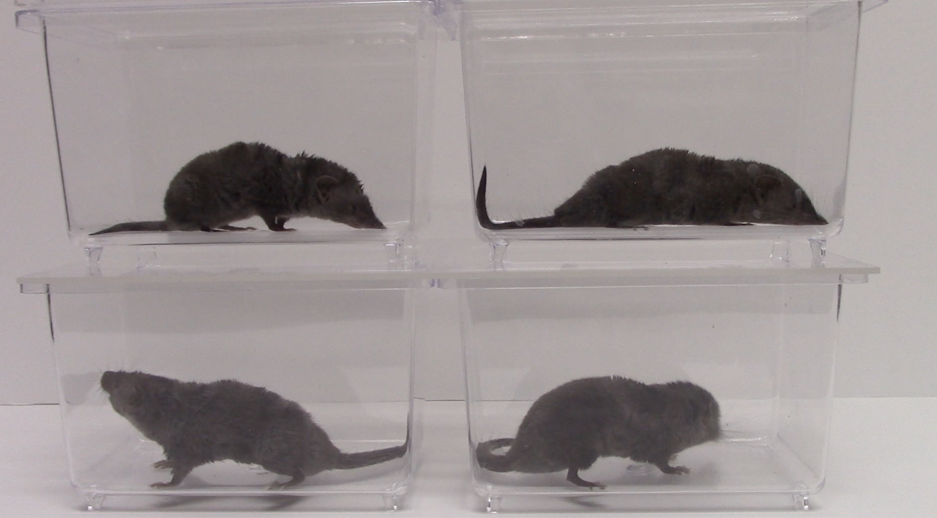

Shrew1

Shrew2

Shrew3

Shrew4

Each shrew cropped and saved for separate video (all trimmed starting at 5:11)

nicotine _10.19.21_shrew1.mp4

nicotine _10.19.21_shrew2.mp4

nicotine _10.19.21_shrew3.mp4

nicotine_10.19.21_shrew4.mp4

Animal Behavior Notes

* Shrew 1 retched the most
* Shrew 3 did not retch
* Shrew 2 and 4 snout slightly out of focus most of the time, facing back corner, both retched 1x
* Shrew 4 most active and yawned ~3 times (timestamp recorded as Y)

Watched videos and marked retching episodes as R in document shrew_retching_tracker.xlsx

**DEEPLAB CUTS**

***Frame extraction and labeling done on GUI***

Video clips cropped to only include behavior of interest retching

Only included shrew 1, 2, 4

Grabbed frames specified by g in shrew_retching_tracker.xslx

Labeling considerations

* Retching is a very rapid behavior, despite recording at 60fps many frames are blurry
  + If I label the frame, then the question is where in the movement
  + Unlabeled and then apply SARIMAX filtering to track

“ **Brandon Jackson**

**@backyardbiomech**

[Oct 26 12:04](https://gitter.im/DeepLabCut/community?at=61782702fb3dcd4e884ca976)

The highest density is not necessarily the middle of the movement, it could be the end. Which could be fine and easy to label consistently. If you're only getting a single blurry frame, then I'd probably not label and let some filtering or splining (I fit quintic splines to most things post-tracking anyways) fill in the gaps. If you have several sequential blurry frames, then that gets tricky, and it might be better to try to track it by labelling the blurry frames. It also depends on your objective. Do you want to measure peak velocities during those movements? Are you looking for precision during those quick movements? If so, then I'd probably try to label and track through the blur. If you are looking for more generalized paths, then I'd take the skip and filter route. Also, the blur is not caused by the frame rate, but by the shutter speed. So if you can add some light and make the shutter speed faster, you'd get rid of the blur (but I know that's "difficult" to do after collecting videos!).”

Trained on a 95:5 train:test split

ResNet50

50 CNN lauers

Input image size 224x224

Imgaug python

p-cutoff set to 0.9

filtering

* Arima filter selected
* not make sure to check filtering with plotting trajectories and creating labeled videos

lots of jitter with the abdomen

gonna go ahead